# INVENTORY AND CHECK OUT PREPARED FOR

FLAT 4,

3 SPRING STREET

LONDON

W2 3RA

12TH DECEMBER 2018 / 28TH APRIL 2021

**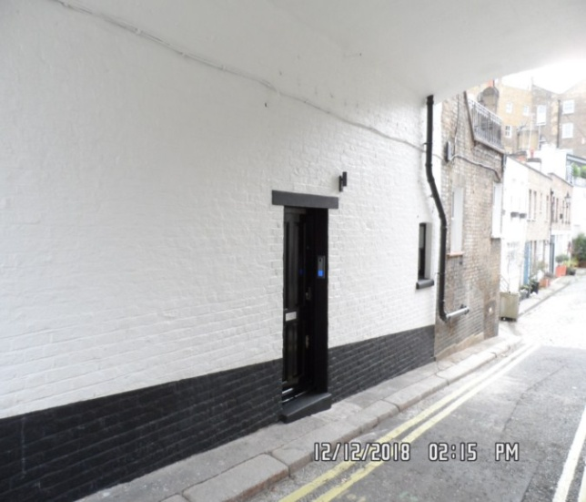**

|  |  |
| --- | --- |
| **CLIENT:** | London Central Portfolio |
| **INSTRUCTED BY:** | Annabel Hughes |
| **JOB NO:** | 2218 |
| **REF:** | MBPS-002 / MBPS-002 |
| **INSPECTED BY:** | Gary Krienkie |
| **PROPERTY SIZE:** | 1 Reception / 1 Bedroom / 1 Bathroom – Furnished Flat |

'WINDY RIDGE' [99 COWLEY HILL, BOREHAMWOOD, HERTS, WD6 5NA](https://maps.google.com/?q=99+COWLEY+HILL,+BOREHAMWOOD,+HERTS,+WD6+5NA&entry=gmail&source=g), TEL: 020 8 386 0950 - MOBILE: 077 67 647 647  
EMAIL: [info@inventorys.net](mailto:info@inventorys.net) [www.inventorys.net](http://www.inventorys.net/)  
Registered No: 4263261 VAT No: 822 9322 12

Safety Disclaimer

This inventory report is prepared as an ‘as seen snapshot’ of the property and its contents at the time of the designated inspection and is compiled as a fair and accurate record for the properties internal condition and contents. This does not form any part of a valuation or structural report.

This inventory is compiled on the basis that all items listed are in good order and clean. Any defects or soiling are noted where appropriate. Where inspections are carried out and the tenants’ belongings are in situ, it can be difficult for clerks to differentiate to that belonging to the landlord or tenant. Should the report contain inaccuracies the clerk (Independent Inventories (UK) Ltd ) will not be held responsible.

The clerk preparing the inventory is not an expert in electrical appliances, antiques, furniture style, fabrics, flooring, etc. All descriptions within this report are for identification purposes only in order that each item can be compared to its condition at the commencement of the tenancy.

Lofts and Cellars are not included unless they are converted and safely accessible. Contents will therefore not be noted or checked at checkin or checkout.

Plants and shrubs will not be itemised.

Belongings left by the landlord/agent in a locked room or outbuilding will not be inventoried and are the sole responsibility of the Landlord/agent. Items in garages/sheds such as garden equipment and tools will be inventoried, however tins of paint will not be itemised.

We do not undertake to move heavy items of furniture or access lofts, high-level cupboards, or any other inaccessible places. Contents which have been left in the above-mentioned areas, which have not been inventoried, are the sole responsibility on the landlord. We also do not undertake to open windows, but will confirm whether keys have been seen or not.

Any electrical appliances tested will be for power only and only where practicable. The clerks are not qualified electricians and will only confirm the visual condition of the electrical socket, wiring and or fitting as seen. Boilers, Heating Systems, Gas Fires, Water Supply and Radiators are not tested, and Independent Inventories (UK) Ltd will not take any responsibility for units left either on or off even if on automatic timers. Where smoke alarms and CO Detectors are tested this is for power only and should not be taken to mean that the alarms are in full working order. We only state their presence and cannot state the functioning of this equipment. No responsibility is taken for any damage or malfunction occurring during the testing of such alarms.

The relevant utility companies must check all meter readings, as we cannot be held responsible for any discrepancies. We are not held liable should meters not be located or inaccessible to read. For Health and Safety reasons we do not expect our clerks to access high level areas which involve using ladders/chairs.

The Fire & safety Regulations regarding furnishings, gas, electrical & similar services are ultimately the responsibility of the instructing principle. Where the inventory notes FFR label seen, this should not be interpreted to mean that the item complies with the furniture & furnishings (fire) (safety) (Amendments) 1993. It is a record that the item had a label as described or similar to that detailed in the Guide to the regulations as published by the Department of Trade & Industry, January 1997, (or subsequent edition), attached at the time the inventory was complied.

Blinds in the premises are visually checked. We are unable to verify that the blinds comply with child safety requirements of BS EN 131202009 + A1:2014 placed on the manufacturer, supplier and professional installation of internal window blinds

It is the responsibility of the landlord/managing agent/tenant to agree between themselves the accuracy of the report, and Independent Inventories (UK) Ltd should be notified within 7 days of receipt of the report of any discrepancies within the report.

GENERAL GUIDANCE NOTES

Independent Inventories do not have site of tenancy agreements or other agreements made between the tenant, landlord and management company. As these are guidance notes only it is always advisable that the tenancy agreement is cross referenced. This report will indicate whether in our opinion the tenant is liable for the deterioration or whether it is considered fair wear & tear. Independent Inventories may suggest maintenance, cleaning or tenant’s liability at checkout, but the final responsibility of these suggestions will fall with the landlord or managing agent in respect of the original tenancy agreement. We do not suggest costs of any items, these should be sourced from the relevant contractors by the landlord or managing agent.

CLEANING

We recommend that a professional cleaning company is employed at the end of the tenancy, unless alternative arrangements have been agreed with the Landlord/Managing Agent. Receipts from professional cleaning and carpet cleaning companies must be present to the clerk at the checkout inspection.

If the standard of cleaning is not satisfactory most Landlords/Managing Agents will contract a cleaner and their charges will be charged to the tenant unless otherwise stated in the tenancy agreement.

DECORATION

It is accepted that during the course of the day to day living scuffs will appear on walls and woodwork. However should the marks be found to be excessive charges will be made to you the tenant, unless otherwise stated in the tenancy agreement.

LIGHTING

If the lights are working at checkin then it is normal, if lights are not working at checkout, for these to be the responsibility of the tenant to replace bulbs or to be charged accordingly, unless otherwise stated in the tenancy agreement.

GARDENS/PATIO

If the standard of the garden/patio is found to be untidy compared to the start of the tenancy the Landlord/Managing Agent are entitled to employ a contract gardener and the charge will be made to you the tenant, unless otherwise stated in the tenancy agreement.

MAINTENANCE ISSUES

We recommended should any maintenance issues arise you contact the Landlord/Managing Agent immediately so they can deal with the matter. Should we recommend items require maintenance once a property has been checked out, this is purely stating that an item will require fixing/attention, we are not advising as to whose responsibility this and your tenancy agreement will need to be checked.

CHANGES TO PROPERTY

We recommend that if you wish to make any changes to the décor or remove any of the Landlords belongings you contact the Landlord/Managing Agent for permission and have this confirmed in writing to ensure there are no discrepancies at the end of the tenancy.

TENANTS INFORMATION FOR CHECKING OUT OF PROPERTY

It is important at the checkout that:

1. All cleaning should be completed prior to the checkout appointment as per the tenancy agreement.
2. All personal items must be removed prior to the check out.
3. All items should be in the same location as per the inventory, any stored items should be unpacked and also returned to the same location.
4. If the Inventory clerk has to search for items or you still have belongings in the property to be removed this will result in additional charges being made to the tenant.
5. All beds should be left unmade with the linen folded. Bedding & towels should be cleaned & ironed where relevant.
6. All food items should be removed, freezers defrosted & doors left open & electricity turned off.
7. All light bulbs etc. should all be in working order as at check in.

The property should be left in a clean and tidy condition especially carpets, curtains, windows, upholstery appliances etc. We would suggest that you refer to your tenancy agreement in this matter.

If you are not ready to leave it may not be possible to carry out the checkout. In this case a return visit will be necessary resulting in a cancellation charge.

All keys to the property must be handed over at the time of checking out to the Inventory clerk or alternatively to the agents prior to the check out taking place.

The Inventory Clerk acts as an independent and reasonable body and will avoid unnecessary criticism or derogatory comments when compiling or checking the Inventory.

At the termination of the tenancy the inventory will be checked and any obvious or significant discrepancies will be reported to the Managing Agent/Instructing Principal. This report will indicate whether in our opinion the tenant is liable for the deterioration or whether it is considered fair wear & tear. Normal fair wear and tear will be assessed on the lengthy of the tenancy and type occupancy.

INDEX

PAGE

|  |  |
| --- | --- |
| UTILITY READING | 1-2 |
|  |  |
| KEYS | 3 |
|  |  |
| GENERAL SUMMARY AT CHECKIN | 4 |
|  |  |
| INSTRUCTION MANUALS | 5 |
|  |  |
| ENTRANCE HALLWAY | 6-10 |
|  |  |
| KITCHEN / RECEPTION | 11-26 |
|  |  |
| BATHROOM | 27-32 |
|  |  |
| BEDROOM | 33-39 |
|  |  |
| DECLARATION AT CHECK IN | 40 |
|  |  |
| ADDITIONAL AMENDMENTS | 41 |
|  |  |
| SIGNED SCHEDULE OF CONDITION AT CHECK IN | 42-44 |

**UTILITY READINGS / KEY LIST& INSTRUCTION MANUALS**

|  |  |  |
| --- | --- | --- |
| **ELECTRIC** | **GAS** | **WATER** |
| METER NUMBER:  D14A210819 | METER NUMBER:  N/A | METER NUMBER:  N/A |
| READING:  00332 | READING:  N/A | READING:  N/A |
| LOCATION:  Communal hallway cupboard | LOCATION:  N/A | LOCATION:  N/A |
| SUPPLIER: | SUPPLIER: | SUPPLIER: |

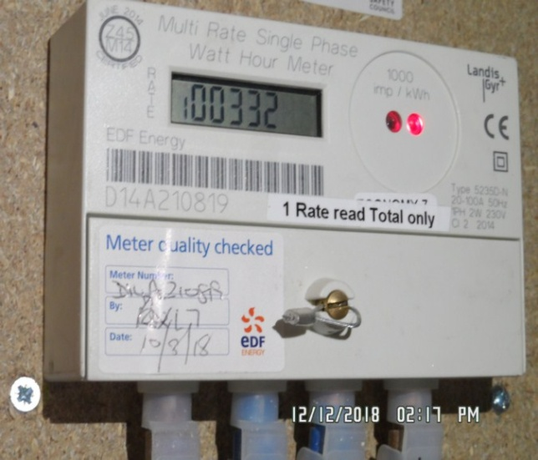

|  |  |  |
| --- | --- | --- |
| **ELECTRIC** | **GAS** | **WATER** |
| METER NUMBER:  D14A210819 | METER NUMBER:  N/A | METER NUMBER:  N/A |
| READING:  15157 | READING:  N/A | READING:  N/A |
| LOCATION:  Communal hallway cupboard | LOCATION:  N/A | LOCATION:  Utility room. |
| SUPPLIER: | SUPPLIER: | SUPPLIER: |

|  |
| --- |
| **LOCATION OF:** |

|  |  |  |
| --- | --- | --- |
| **STOP COCK** | Not located | |
| **FUSE BOARD** | Hallway | |
| **ALARM PANEL**  **This has not been tested** | None | MAKE: |

|  |
| --- |
| **FIRE SAFETY** |

|  |  |
| --- | --- |
| **SMOKE ALARM** | Mains powered and Power light on  Tested with canned smoke and working order |
| **CARBON MONOXIDE ALARM** | N/A |

|  |  |  |
| --- | --- | --- |
| **KEYS AT CHECKIN** | **KEYS AT CHECKOUT** | |
| **KEY TYPE / SERIAL NUMBER / QTY** | **KEY TYPE / SERIAL NUMBER / QTY** |
| 2 x Silver Bramah (EA178889, EA1788N08) |  |
|  |  |
|  |  |
|  |  |
|  |  |
|  |  |
| **KEYS RECEIVED BY: Agent (Hannah Rooney)**  \\Pc-1\mbps\II\13TH DEC\13TH DEC\flat 4, 3 spring street - make\Pictures\New folder\SAM_0825 (Copy).JPG | **KEYS RETURNED TO: Picked up and dropped off at LCP, picture of keys taken \*\*\*** | |

|  |
| --- |
| **GENERAL SUMMARY** |

|  |  |  |
| --- | --- | --- |
| **ITEM** | **CHECKIN NOTES** | **CHECKOUT NOTES** |

|  |  |  |  |
| --- | --- | --- | --- |
| **GENERAL CONDITION** | | Professionally cleaned for start of tenancy | Professionally cleaned for end of tenancy |
| **ODOUR** | | N/A | N/A |
| **DECORATIVE ORDER / WOODWORK** | | Advised freshly painted  Good order | Defects as noted  Woodwork scuffed/chipped |
| **FLOORING** | | Good order  Vacuumed for start of tenancy  New | Vacuumed for end of tenancy  Defects as noted |
| **CURTAINS / BLINDS** | | Good order  New | Defects as noted |
| **BLIND REGULATIONS** | | Chain tidy in place |  |
| **UPHOLSTERY** | | New | Vacuumed in situ for end of tenancy  Defects as noted |
| **FFR LABELS** | FFR labels seen | |  |
| **LINEN** | New | | In use  Requires further cleaning |
| **LIGHTS** | All working order | | All working order |
| **KITCHEN / APPLIANCES** | All clean order  All appliances power tested  Fridge/ freezer left shut power on  New | | All clean order  All appliances power tested  Fridge/ freezer left shut power on |
| **BATHROOMS/**  **WC** | Clean  All fitments free of lime scale  Water outlets tested and working | | Clean  Water outlets tested and working |
| **WINDOWS** | Fitments complete  Clean to interior / exterior | | Fitments complete  Clean to interior  Requires further cleaning |
| **GARDEN /**  **TERRACE** | N/A | | N/A |

|  |  |
| --- | --- |
| **MANUALS SUPPLIED AT**  **CHECKIN** | **MANUALS RETURNED AT**  **CHECKOUT** |
| **APPLIANCE / MAKE** | **APPLIANCE/MAKE** |
|  |  |
|  |  |
|  |  |
|  |  |
|  |  |

 \*N.B – Heavy items will not be moved or inspected behind/under, for health & safety reasons. We will not be held liable should any damages/stains/marks be found during the tenancy in these areas. Should the occupant find any of the above they should, inform the landlord/agent immediately and if/where possible take photographic evidence and pass to the relevant parties.

 This camera symbol throughout the Inventory check in/out indicates where a photo has been taken. Photos can be found at the back of each room in the report with the relevant headings

**ENTRANCE HALLWAY**

|  |  |  |  |
| --- | --- | --- | --- |
| **Door** | Exterior Door Frame  Painted dark grey frame | 1. Appears to be freshly painted 2. Old defects underneath |  |
|  | Exterior Door  Painted dark door with 6 x panels    Brushed stainless steel door closer  Brushed stainless steel “4”  Brushed stainless steel lever handle with matching surround  Brushed stainless steel Yale lock with matching surround  Sign Fire Door Keep shut attached at high level | 1. Freshly painted 2. 1 or 2 x white scuffs seen at high level 3. All attachments newly in stored |  |
|  | Interior Door Frame  Painted dark grey frame | 1. Appears to be freshly painted 2. Old defects underneath |  |

**ENTRANCE HALLWAY**

|  |  |  |  |
| --- | --- | --- | --- |
| **Door contd..,** | Interior Door  Dark grey wooden door with 6 x panels  Brushed stainless steel lever handle with matching surround  Brushed stainless steel twist lock with matching surround  Signs indicating fire door keep shut | 1. All attachments newly in stored 2. Freshly painted |  |
| **Walls** | Painted white | 1. Freshly painted |  |
| **Ceiling** | Painted white | 1. Freshly painted |  |

**ENTRANCE HALLWAY**

|  |  |  |  |
| --- | --- | --- | --- |
| **Lights** | 1 x recessed spotlight white metal surround | 1. Tested and working for power |  |
| **Woodwork** | Skirting painted white | 1. Freshly painted |  |
| **Switches and sockets** | Black onyx switches and sockets | 1. All appear to be intact |  |
| **Flooring** | Light wooden laminate flooring | 1. Newly in stored |  |

**ENTRANCE HALLWAY**

|  |  |  |  |  |
| --- | --- | --- | --- | --- |
| **Thermostat control** | 1 x white plastic thermostat control | 1. Intact 2. Not tested for power |  |  |
| **Smoke alarm** | 1 x smoke alarm | 1. Green light showing 2. Expiration date May 2029 3. Tested and working for power |  |  |
| **Fuse box** | 1 x white metal fuse box with matching flap | 1. Newly in stored |  |  |

Exterior door Entrance hallway

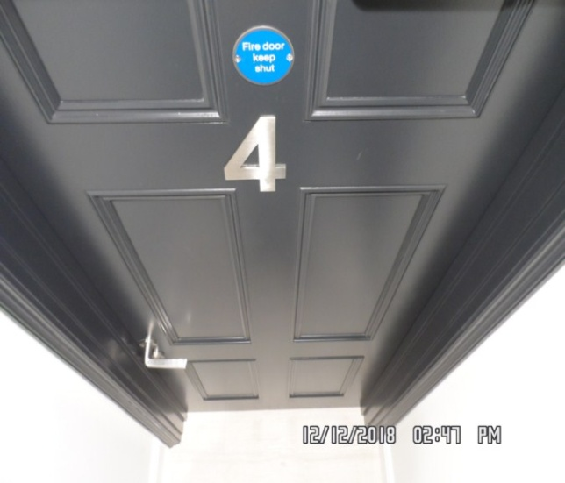 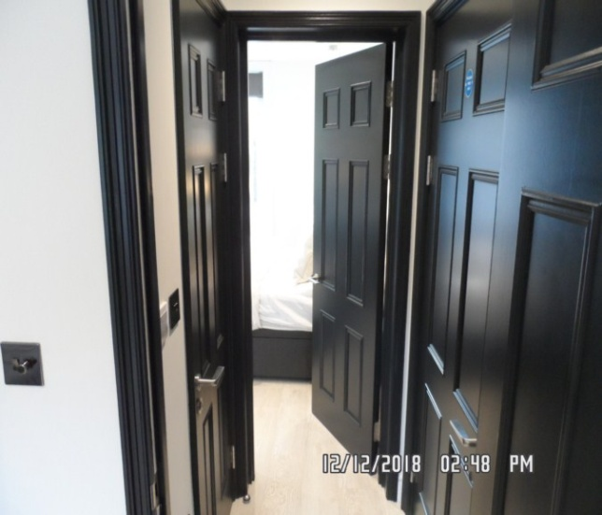

Entrance hallway Entrance hallway

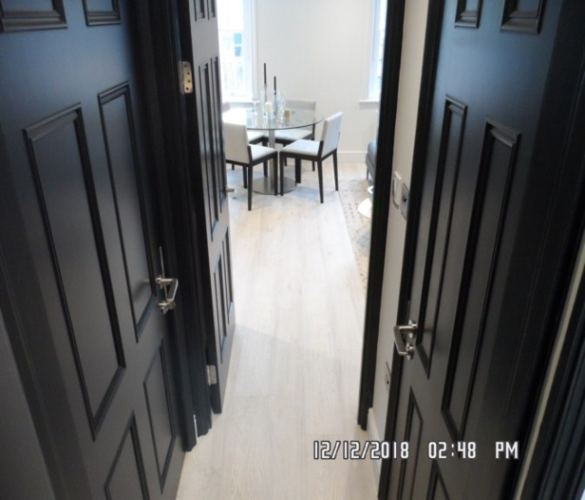 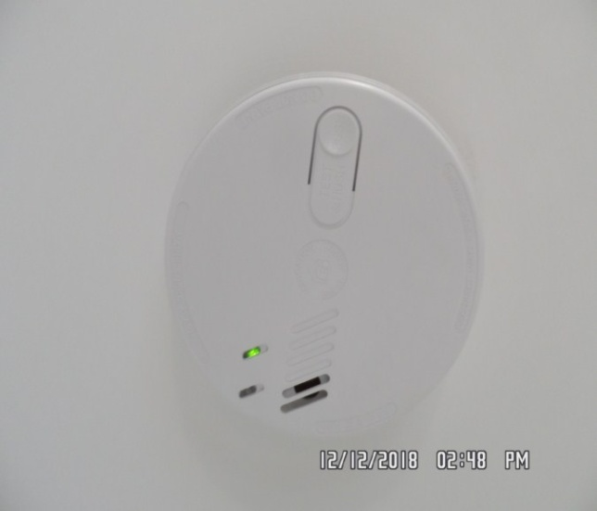

**KITCHEN / RECEPTION**

|  |  |  |  |
| --- | --- | --- | --- |
| **Door** | Exterior Door Frame  Painted dark grey frame | 1. Freshly painted |  |
|  | Exterior Door  Painted dark grey door  Brushed stainless steel lever handle with matching surround | 1. Freshly painted 2. All attachments newly in stored |  |
|  | Interior Door Frame  Painted dark grey frame | 1. Freshly painted |  |
|  | Interior Door  Painted dark grey door with 6 x panels  Brushed stainless steel lever handle with matching surround | 1. Freshly painted 2. All attachments newly in stored |  |

**KITCHEN / RECEPTION**

|  |  |  |  |
| --- | --- | --- | --- |
| **Walls** | Part painted white  Part white perspex splashback | 1. Freshly painted 2. Splashback newly in stored 3. Right hand side wall at high level appears to have some unpainted plaster seen at high level |  |
| **Ceiling** | Painted white | 1. Freshly painted |  |
| **Lights** | 9 x recessed spotlights with white metal surrounds  3 x strip lights seen to the underside of the kitchen units | 1. All tested and working |  |
| **Woodwork** | Skirting painted white | 1. Freshly painted |  |
| **Switches and sockets** | Black onyx | 1. All appear to be intact and in good order 2. Newly in stored |  |

**KITCHEN / RECEPTION**

|  |  |  |  |
| --- | --- | --- | --- |
| **Windows** | White wooden encasement and frame single glazed  Each window has 1 x fixed panel at high level and 1 x opening panel at low level  Each section has 3 x glass panels  2 x brushed stainless steel pull handles to each window  1 x brushed stainless steel twist lock to each window  2 x brushed stainless steel locks attached  Sill painted white | 1. Freshly painted 2. Sash cords intact 3. Around the edges of the glazing slight paint marks and scattered heavy scratches seen 4. Sill freshly painted |  |
| **Curtains** | Dark grey fabric Roman blind  Stainless steel beaded chain with chain tidy in place | 1. Newly in stored |  |
| **Flooring** | White wooden laminate flooring  Doorstop mounted to the floor brushed stainless steel and black rubber tipped | 1. Newly in stored 2. Vacuumed for the start of tenancy 3. Doorstop intact |  |

**KITCHEN / RECEPTION**

|  |  |  |  |
| --- | --- | --- | --- |
| **Radiator** | 2 x Nobo electric white painted single panelled metal radiators with Led display | 1. Currently showing power to both units 2. Newly in stored 3. Not tested for power |  |
| **Unit Description - Units are inspected from left to right** | Kitchen units are navy blue wooden laminate to both interior and exterior  Brushed stainless steel handles  White wooden laminate to interior  Kickboards matching colour to exterior kitchen units | 1. All kitchen units newly in stored 2. Clean to both interior and exterior |  |
| **Wall unit 1** | Double opening door unit with 3 x shelves and 1 x base shelf  Plug sockets to interior with 1 x oven, dishwasher, fridge, fan and spur  1 x separate hob switch |  |  |
| **Wall unit 2** | Single opening unit with 2 x shelves and 1 x base shelf  Remote seen to interior for TV |  |  |

**KITCHEN / RECEPTION**

|  |  |  |  |
| --- | --- | --- | --- |
| **Wall unit 3** | Single opening unit with 3 x shelves and 1 x base shelf  2 x silver aluminium frames seen to interior |  |  |
| **Wall unit 4** | Single opening unit with 3 x shelves and 1 x base shelf |  |  |
| **Wall unit 5** | Single opening unit with 3 x shelves and 1 x base shelf  Attachment for kettle and assortment of crockery and cutlery seen dining table |  |  |
| **Floor units (inspected from left to right)** |  |  |  |
| **Floor unit 1** | Single opening unit with 1 x base shelf |  |  |

**KITCHEN / RECEPTION**

|  |  |  |  |
| --- | --- | --- | --- |
| **Floor unit 2** | Single opening unit with 1 x base shelf  Rear wall cut-out for associated pipework  1 x water Salter to interior |  |  |
| **Work surface** | White wooden laminate worktop with silver strip to the front edges | 1. Newly in stored 2. Clean to the top surface |  |
| **Sink** | Brushed stainless steel sink with matching drainer plug  Stainless steel integrated mixer tap | 1. Clean to interior |  |
| **Extractor** | Silver metal encasement  1 x filter cover and 1 x light cover  2 x lights to interior | 1. Tested and working for power 2. Brand name and model not seen 3. When operating extractor fan door slightly stiff |  |

**KITCHEN / RECEPTION**

|  |  |  |  |
| --- | --- | --- | --- |
| **Hob** | Black induction Hotpoint hob with 4 x plates | 1. Clean to the top surface 2. Appears to be newly in stored 3. Serial number and model not seen |  |
| **Oven** | Indesit oven brushed stainless steel black and clear viewing glass to exterior serial number 804020324 and type FXJM6  Brushed stainless steel handle  3 x silver plastic knob control  1 x stainless steel rack  1 x grey grill pan | 1. Tested and working for power |  |
| **Fridge/ freezer** | Hotpoint fridge/ freezer serial number 111822004534 and model number HMCB5050AA.UK  3 x clear plastic door shelves  3 x glass shelves brushed stainless steel trim  1 x clear plastic salad crisper drawer  1 x light and light cover  Manuals seen  Salad crisper and 3 x clear plastic freezer drawers |  |  |

**KITCHEN / RECEPTION**

|  |  |  |  |
| --- | --- | --- | --- |
| **Dishwasher** | Indesit dishwasher type DWS-DEA603-8 and serial number 451825023226  2 x white metal crockery racks and 1 x grey plastic cutlery rack | 1. Units is brand new 2. Newly in stored 3. Tested and working for power 4. Clean to interior |  |
| **Washing machine** | Indesit washing machine model number IWEM147 and serial number 581815001007 | 1. Soap tray clean to interior 2. Sealant to interior clean to interior 3. Brand new 4. Tested and working for power |  |
| **Heat alarm** | 1 x heat alarm | 1. Green light showing 2. Tested and working for power 3. Expiration date May 2029 |  |

**KITCHEN / RECEPTION**

|  |  |  |  |
| --- | --- | --- | --- |
| **Entry phone** | 1 x BPT entry phone model OPALE | 1. Tested only for power |  |
| **Sofa** | 1 x “L” shaped grey fabric sofa on stainless steel legs  2 x seater cushions and 3 x rear cushions  3 x matching cushions with 4 x light grey scatter cushions | 1. All appear to be brand new 2. FFR label seen |  |
| **Rug** | 1 x light brown rug with black print to the top surface | 1. Brand new 2. Vacuumed for the start of tenancy |  |
| **Coffee table** | 1 x triangular coffee table with stainless steel base  White wooden laminate top | 1. Appears to be brand new |  |

**KITCHEN / RECEPTION**

|  |  |  |  |
| --- | --- | --- | --- |
| **Side table** | White plastic moulded unit side table | 1. Appears to be intact |  |
| **Lamp** | 1 x freestanding lamp  Brushed stainless steel base and stem with white shade | 1. Tested and working for power |  |
| **Shelves** | 2 x dark grey wall mounted shelves – 1 x to rear and 1 x to the right hand side | 1. Both appear to be newly in stored |  |
| **TV** | 1 x Techwood TV  1 x remote seen | 1. Serial number and model unable to inspect as it is currently mounted to the wall |  |
| **Print** | 1 x black print with cat  Clear plastic protector | 1. Intact |  |

**KITCHEN / RECEPTION**

|  |  |  |  |
| --- | --- | --- | --- |
| **Contents** | 5 x various side glass vases  3 x brushed stainless steel fruit bowls  2 x various size brushed stainless steel candle holders  4 x white frosted glass vases  2 x silver aluminium picture frames | 1. All items appear to be brand new |  |
| **Dining table** | 1 x glass top dining table brushed stainless steel base and stem  4 x light grey fabric chairs included black wooden laminate frame | 1. Clean to the top surface 2. Appears to be all brand new |  |
| **Magazine** | Assortment of design magazine seen on coffee table |  |  |

**KITCHEN / RECEPTION**

|  |  |  |  |
| --- | --- | --- | --- |
| **Crockery** | 4 x knives  4 x forks  4 x spoons  4 x table spoons  3 x medium wine glasses  1 x white ceramic dinner plate  1 x matching side plate  1 x matching bowl |  |  |
| **Kettle** | 1 x Haden grey kettle | 1. Brand new |  |
| **Canisters** | 3 x white metal canisters with light wooden lids labelled tea, coffee and sugar | 1. All brand new |  |

**KITCHEN / RECEPTION**

|  |  |  |  |
| --- | --- | --- | --- |
| **Chopping board** | Grey and white marble chopping board | 1. Units brand new |  |
| **Saucepans** | 3 x various sizes stainless steel saucepans with glass lid |  |  |

Kitchen / Reception Kitchen / Reception

**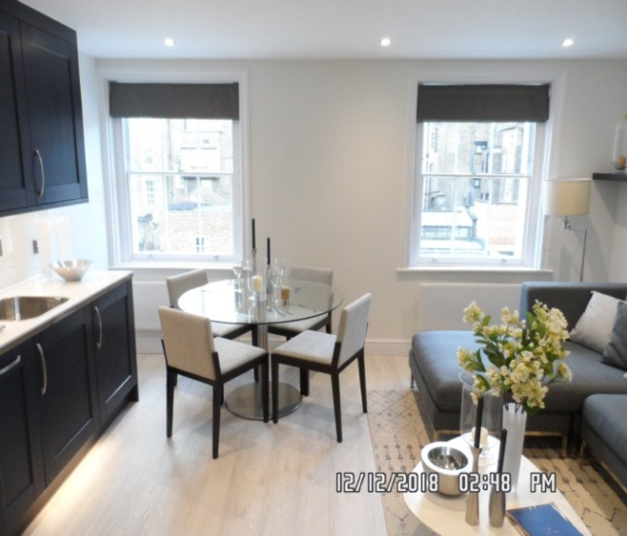 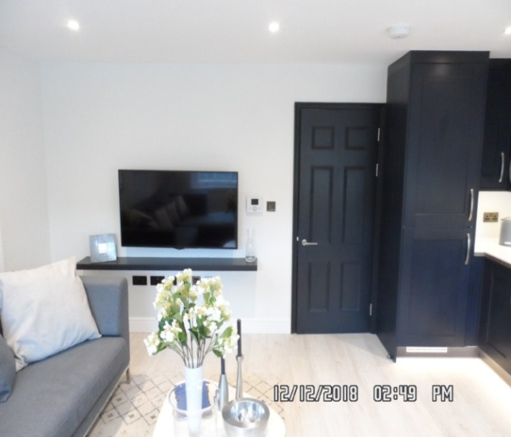**

Kitchen / Reception Kitchen / Reception

**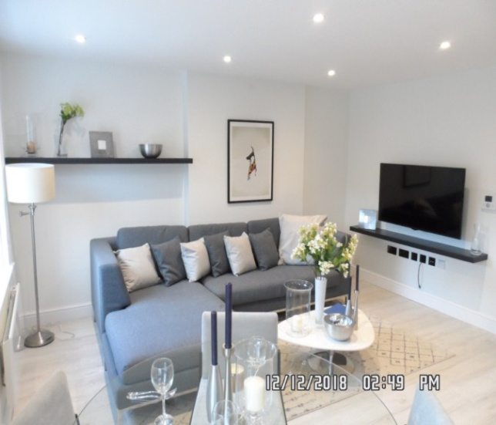 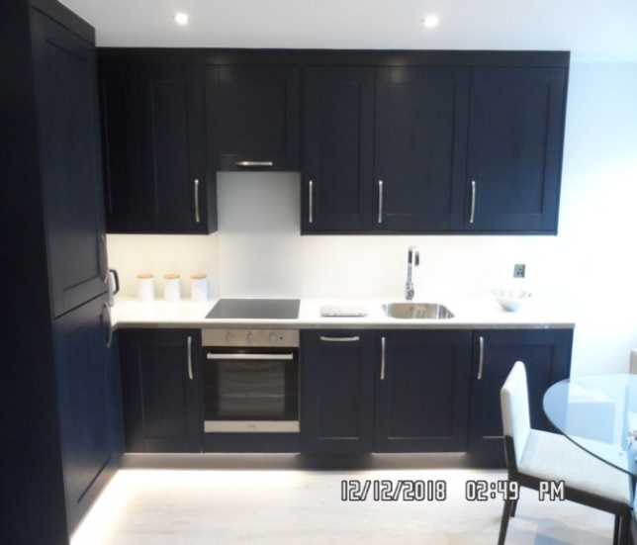**

Kitchen / Reception Fridge/ freezer

**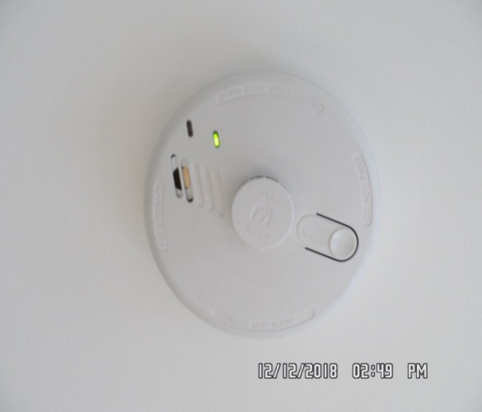 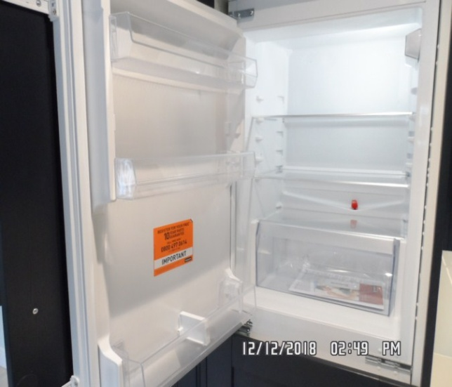**

Fridge/ freezer Extractor

**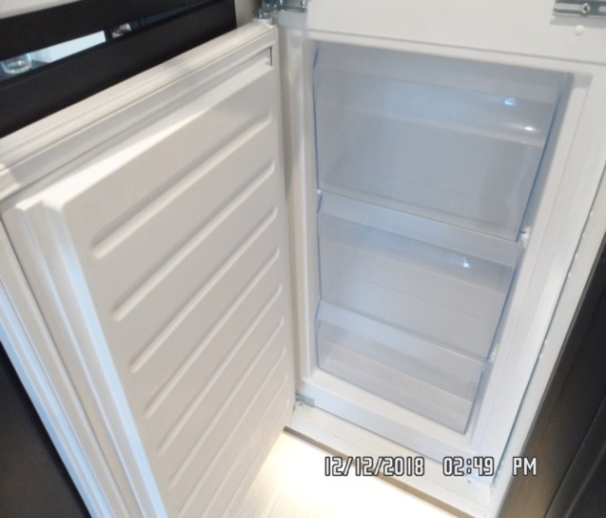 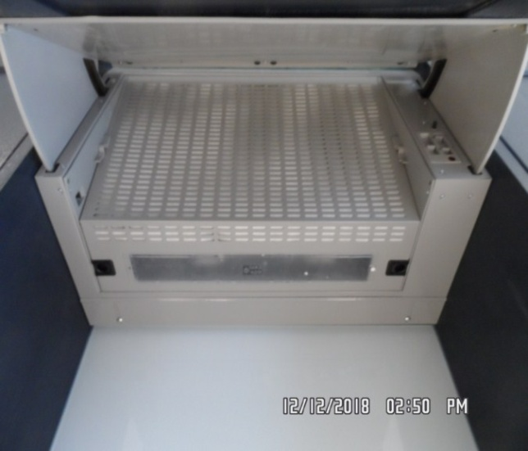**

Hob Oven

**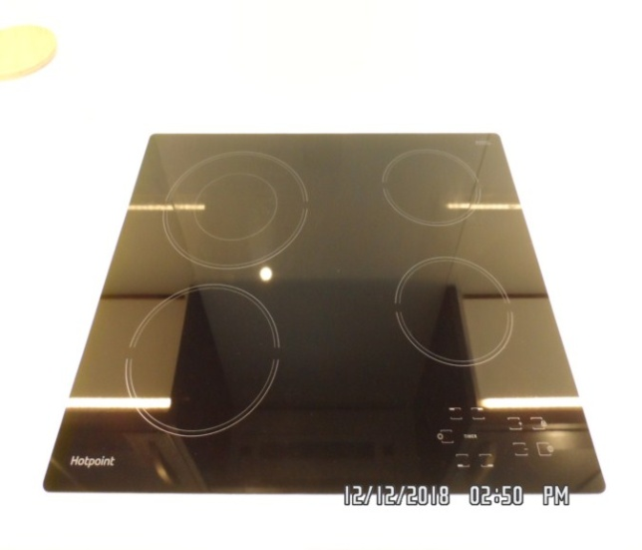 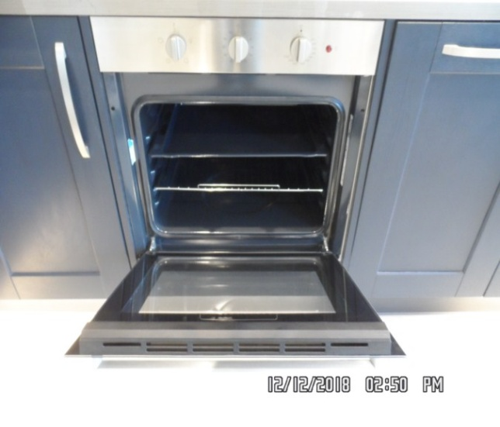**

Sink Dishwasher

**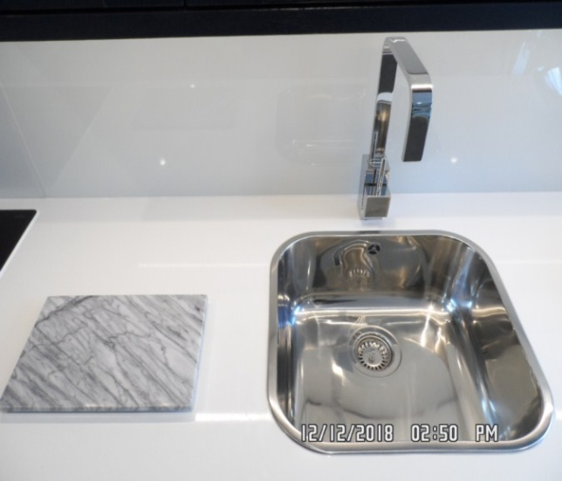 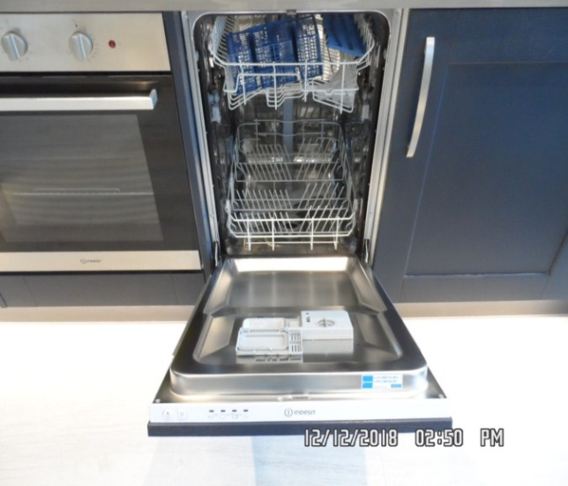**

Washing machine Kitchen / Reception

**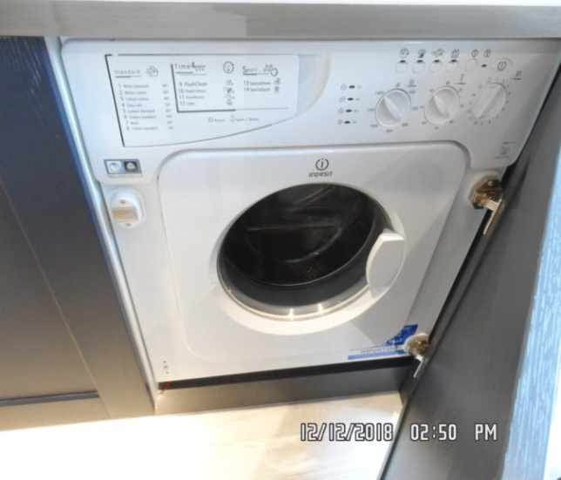 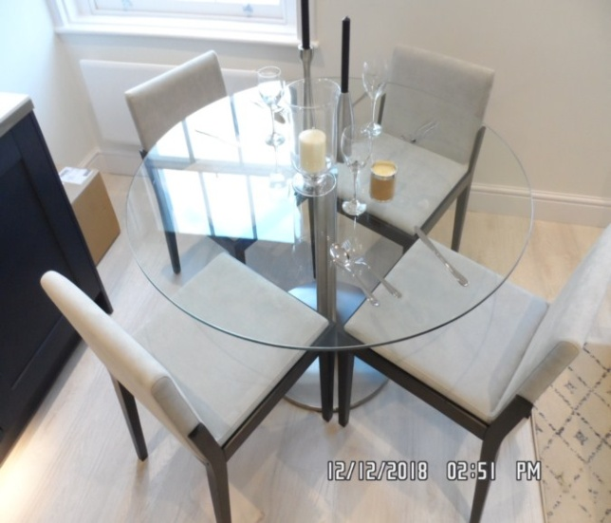**

Kitchen / Reception

**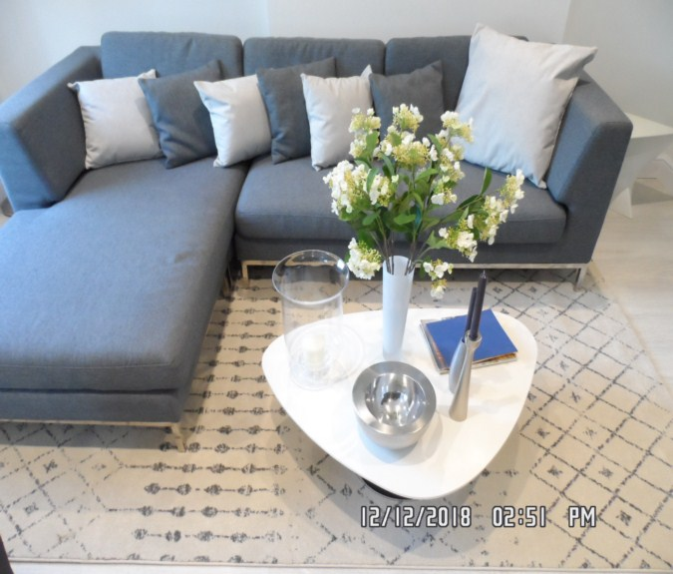**

**BATHROOM**

|  |  |  |  |
| --- | --- | --- | --- |
| **Door** | Exterior Door Frame  Painted dark grey frame  Throughout upon entrance brushed stainless steel | 1. Freshly painted 2. Threshold newly in stored |  |
|  | Exterior Door  Painted dark grey door with 6 x panels  Brushed stainless steel lever handle with matching surround  Brushed stainless steel twist lock with matching surround | 1. Freshly painted |  |
|  | Interior Door Frame  Painted dark grey frame | 1. Freshly painted |  |
|  | Interior Door  Painted dark grey door with 6 x panels  Brushed stainless steel lever handle with matching surround  Brushed stainless steel twist lock with matching surround  3 x stainless steel hooks | 1. Freshly painted |  |

**BATHROOM**

|  |  |  |  |
| --- | --- | --- | --- |
| **Walls** | Part white ceramic tile with white grout  Part white and grey marble effect ceramic tile with white grout  Silver aluminium trim along the edges of the tiles | 1. Tiles to walls all newly in stored |  |
| **Ceiling** | Painted white | 1. Freshly painted |  |
| **Lights** | 3 x recessed spotlights with white metal surrounds | 1. All tested and working for power |  |
| **Switches and sockets** | 1 x white plastic shaver only  socket |  |  |

**BATHROOM**

|  |  |  |  |
| --- | --- | --- | --- |
| **Flooring** | White and grey marble ceramic tile with white grout | 1. Newly in stored |  |
| **Radiator** | Stainless steel ladder style unit | 1. Newly in stored |  |
| **Basin** | Wall mounted white ceramic basin  Stainless steel integrated mixer tap  Stainless steel surround and popup plug  Silver plastic overflow cap |  |  |
| **Toilet** | White ceramic toilet with matching cistern  Stainless steel flush  White plastic toilet seat and lid | 1. Clean to interior |  |

**BATHROOM**

|  |  |  |  |
| --- | --- | --- | --- |
| **Shower cubicle** | Stainless steel hinges  Built in-folding door glass panels  Stainless steel handle to exterior, stainless steel knob handle to interior  White enamel shower tray  Silver plastic overflow cap    1 x Aquas silver plastic shower heating system with silver plastic showerhead  Stainless steel shower hose with silver plastic showerhead and further shower riser for showerhead | 1. Clean to interior 2. Newly in stored 3. Not tested 4. Appears to be newly in stored |  |
| **Extractor fan** | 1 x Xpelair white plastic | 1. Tested and working for power |  |
| **Medicine cabinet** | 1 x medicine cabinet white wooden laminate to both interior and exterior  Mirrored panel to exterior door  4 x shelves and 1 x base shelf | 1. Newly in stored |  |

**BATHROOM**

|  |  |  |  |
| --- | --- | --- | --- |
| **Toilet roll holder** | 1 x stainless steel toilet roll holder | 1. Intact |  |
| **Towels** | 2 x white towels | 1. Both brand new |  |

Bathroom Toilet

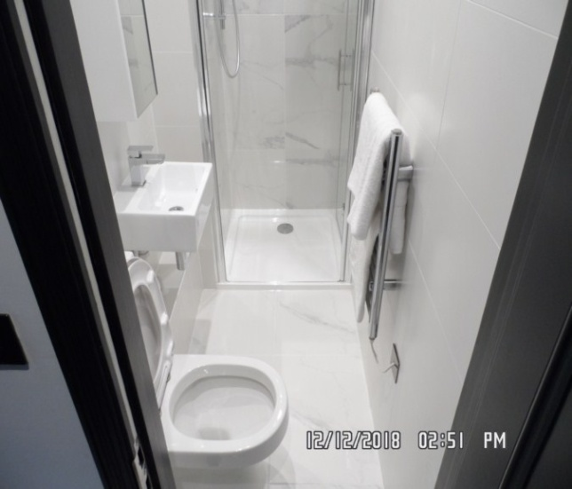 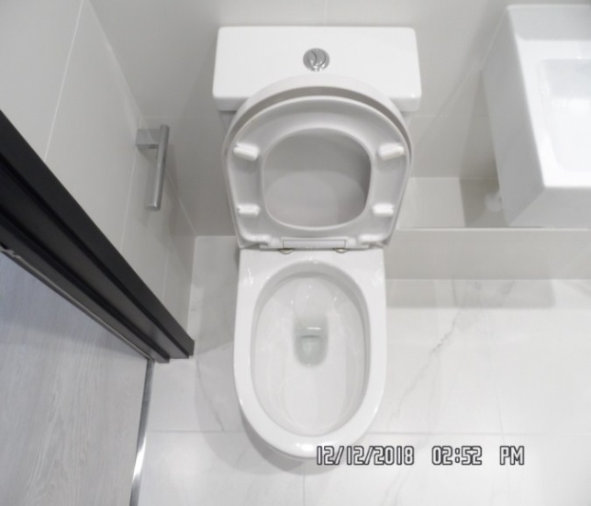

Basin Shower

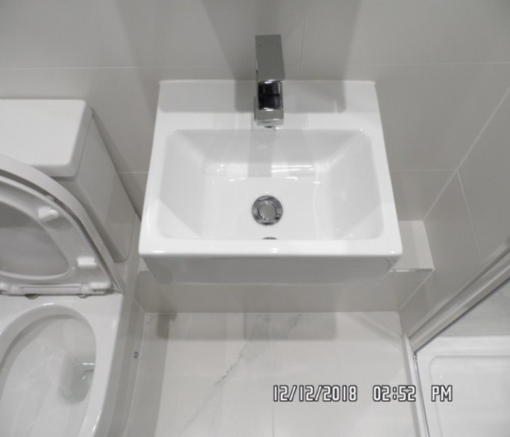 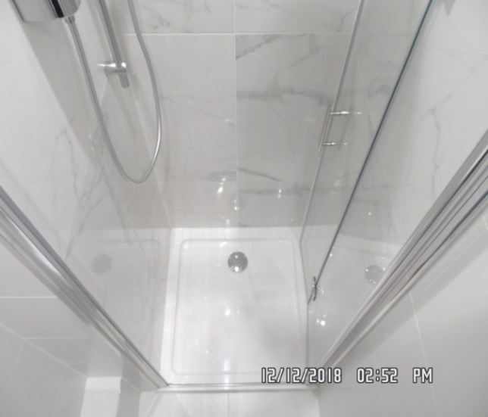

Bathroom Bathroom

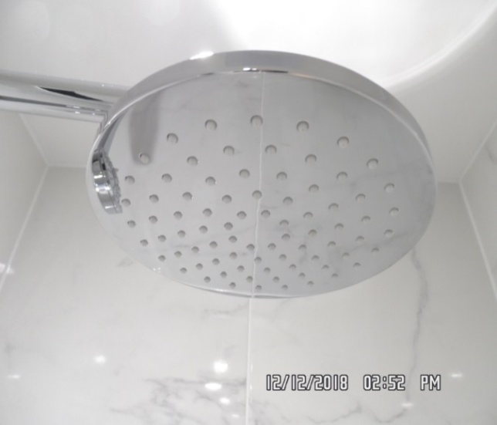 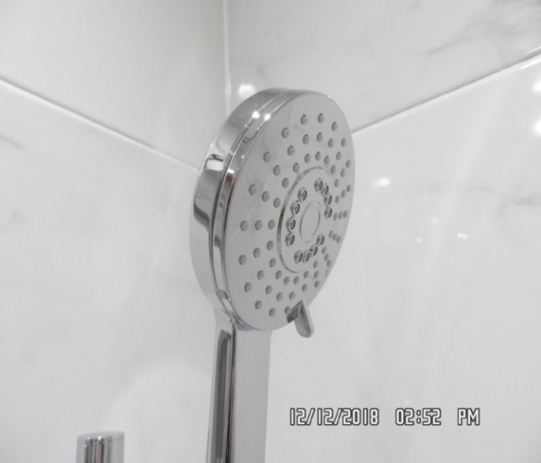

Bathroom

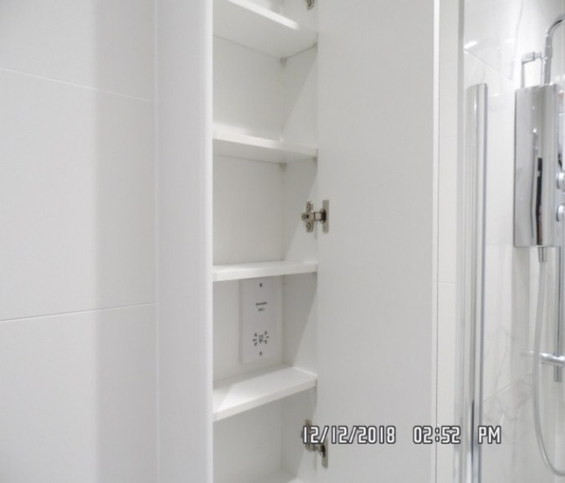

**BEDROOM**

|  |  |  |  |
| --- | --- | --- | --- |
| **Door** | Exterior Door Frame  Painted dark grey in colour | 1. Freshly painted |  |
|  | Exterior Door  Painted dark grey in colour  6 x panels to either side of door  Brushed stainless steel lever handle with matching surround | 1. Freshly painted 2. Handle newly installed |  |
|  | Interior Door Frame  Painted dark grey in colour | 1. Freshly painted |  |
|  | Interior Door  Painted dark grey in colour  6 panels to either side of door  Brushed stainless steel lever handle with matching surround | 1. Freshly painted 2. Handle newly installed |  |

**BEDROOM**

|  |  |  |  |
| --- | --- | --- | --- |
| **Walls** | Painted white | 1. Freshly painted |  |
| **Ceiling** | Painted white | 1. Freshly painted |  |
| **Lights** | 5 x recessed spotlights with 1 x metal surround  2 x pendant lights with frosted glass shades  1 x strip light to the rear of the headboard | 1. All lights tested and working |  |
| **Woodwork** | Painted white | 1. Freshly painted |  |

**BEDROOM**

|  |  |  |  |
| --- | --- | --- | --- |
| **Switches and sockets** | Black annex | 1. Intact |  |
| **Windows** | White wooden and casement frame, sash style with 1 x fixed high level and 1 x opening  Each section has 2 x glass panels  Sash cords  Attachments include brushed stainless steel twist lock  2 x brushed stainless steel pull handles  2 x stainless steel locks | 1. Cords intact 2. All freshly painted |  |  |
| **Curtains** | Grey Roman blind with stainless steel beaded chain | 1. Chain tidy intact 2. Newly installed |  |  |
| **Flooring** | White wooden laminate flooring | 1. Newly installed 2. Vacuumed for the start of tenancy |  |  |

**BEDROOM**

|  |  |  |  |  |
| --- | --- | --- | --- | --- |
| **Radiator** | White painted electric Nobel radiator with LED display | 1. Currently showing power 2. Newly installed |  |  |
| **Built-in Wardrobes** | Mirrored panels to exterior 4 x doors  Brushed stainless steel handle to all doors  To interior:  Painted dark grey  From left to right:  Unit 1:  Single opening unit  4 x shelves  1 x base shelf  Unit 2:  Single sliding door  To interior:  1 x hat shelf  1 x stainless steel hanger rail  1 x base shelf  Unit 3:  Double sliding door  1 x shelf  1 x stainless steel hanger rail  1 x base shelf  Unit 4:  Single sliding door  4 x shelves  1 x base shelf |  |  |  |

**BEDROOM**

|  |  |  |  |  |
| --- | --- | --- | --- | --- |
| **Doorstop** | Brushed stainless steel and black rubber tip | 1. Newly installed 2. Intact |  |  |
| **Bed** | 1 x bed with dark brown double base  2 x drawers either side | 1. Brand new |  |  |
| **Mattress** | White and black striped | 1. Currently fitted, unable to fully inspect |  |  |
| **Linen** | Includes:  1 x white mattress protector  1 x white fitted sheet  1 x further white colour flat sheet  1 x duvet with matching duvet cover  1 x dark grey colour throw  2 x pillows with white pillowcases  2 x light grey colour scatter cushions | 1. All linen and bedding brand new |  |  |

**BEDROOM**

|  |  |  |  |  |
| --- | --- | --- | --- | --- |
| **Headboard** | Painted dark grey with 2 x shelves attached | 1. Intact 2. Freshly painted throughout |  |  |
| **TV Unit** | 1 x TV wall mounted unit Sony  1 x remote seen in wardrobe | 1. Not tested for power |  |  |
| **Vase** | 2 x glass vases with candles to interior | 1. Brand new |  |  |

Bedroom Bedroom

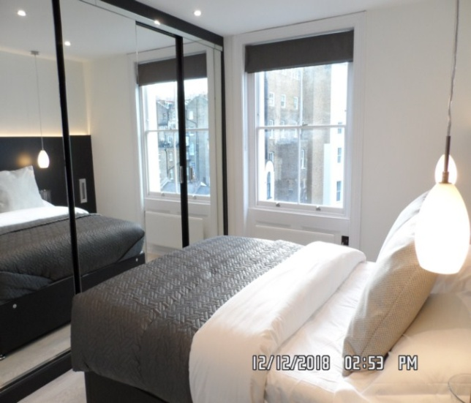 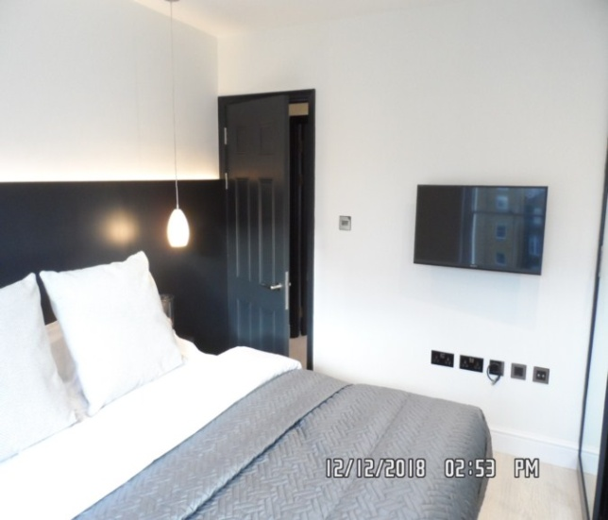

Bedroom Bedroom

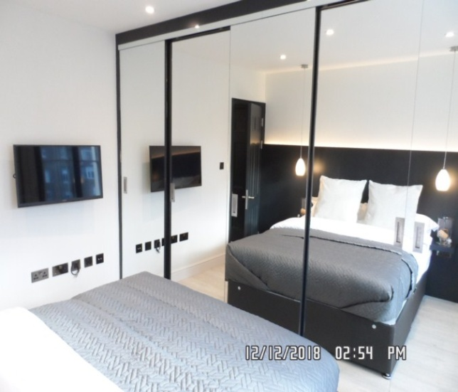 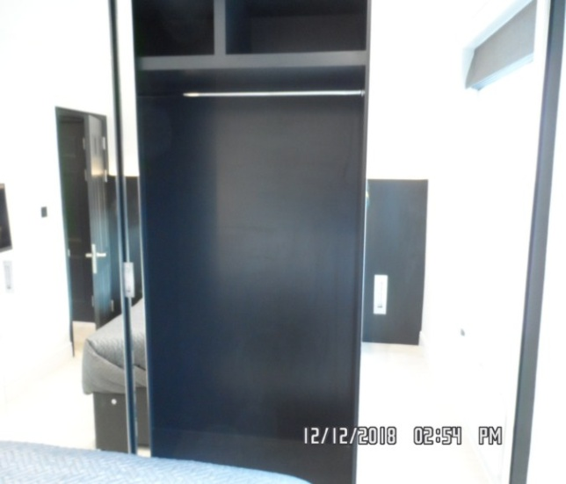

# DECLARATION AT CHECK IN

This inventory has been examined and, subject to marginal comments found to be correct.

## On behalf of the landlord

on behalf of the tenant \_\_\_\_\_

commencement of tenancy **\_\_\_\_\_\_**

## **N.B**

This inventory is correct to the best of our knowledge but advise you to examine its contents prior to signing, as we can not be held responsible for any errors or omissions. Descriptions are for identification purposes only.

The relevant utility companies must check all meter readings, as we can not be held responsible for any discrepancies

**Please ensure that all items listed in this inventory are in the same location at the end of the tenancy.**

**ADDITIONAL AMENDMENTS**

|  |  |  |
| --- | --- | --- |
| DATE | DESCRIPTION OF CHANGES | AGENTS/LANDLORD SIGNATURE |
|  |  |  |
|  |  |  |
|  |  |  |
|  |  |  |
|  |  |  |
|  |  |  |
|  |  |  |
|  |  |  |
|  |  |  |

WHEN ADDITIONS/AMENDMENTS ARE MADE BY THE LANDLORD, TENANT OR AGENT THE RELATIVE PARTIES MUST BE INFORMED

**GENERAL COMMENT**

It should be noted that it is not the responsibility of the Inventory Clerk to open, unpack, empty or itemise items stored in carrier bags

or other containers unless it is made specifically clear they are the property of the Landlord.

